Polynomials 3 7/16

1) 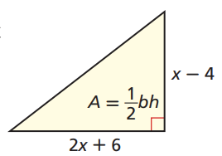

1. Write a polynomial that represents the area of the triangle.

1. Find the area when x = 4.5 in.

2) If ( x + 1)(x + 4) - (x - 1)(x - 2) = 0, what is the value of x?

3) What is the area of a rectangle with a length of x - a and a width of x + b

4) For integers greater than 0, define the following operations.

a☐b=2a2 + 3b

a△b=5a2 - 2b

What is (a☐b)-(a△b)?

5) Ron is making an ice sculpture. The block of ice is in the shape of a rectangular prism with a length of (x + 2) inches, a width of (x - 2) inches, and a height of 2x inches.

1. Write and simplify a polynomial expression for the volume of the block of ice.
2. The final volume of the ice sculpture is (x3 + 4x2 -10x + 1) cubic inches. Write an expression for the volume of ice that Ron carved away.

6) Look at the pentagon.

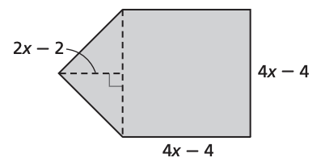

1. Write and simplify an expression that represents the area of the pentagon. Show your work or explain your answer.
2. Show one method of checking that your expression in part A is correct.
3. The triangular part of the pentagon can be rearranged to form a square. Write the area of this square as the square of a binomial.
4. Expand the product that you wrote in part C. What type of polynomial is this?
5. Is the square of a binomial ever a binomial?